**41081 Lab 1 Results**

|  |  |  |  |
| --- | --- | --- | --- |
| **Student Number** | 13555089 | **Student Name** | Ryan Cleminson |
| **Subject ID** | 41081 | **Subject Name** | Sensing Actuation and Control |

**Task 2.1: Seat belt warning system (4 points)**

1. Screenshort of your source code; (2’) (screenshorts of your code is more readble with the variables and keywords highlighted )

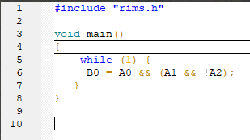

1. Screenshot of the case where: the car on, the driver is not seated **(1 point)**

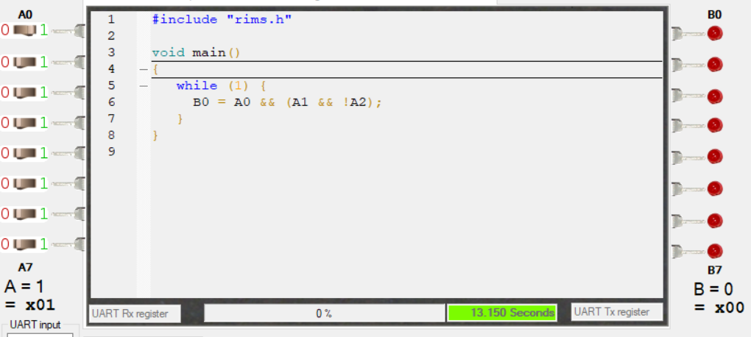

1. Screenshot of the case where the car on, the driver is seated, and the seat belt is not fastened **(1 point)**

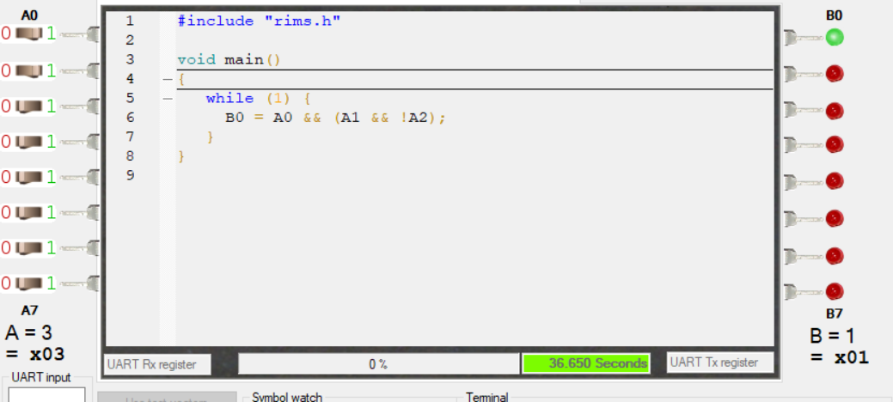

**Task 2.2: RIMS 7-segment display (6 Points)**

1. Screenshort of your source code; (2’**)**

­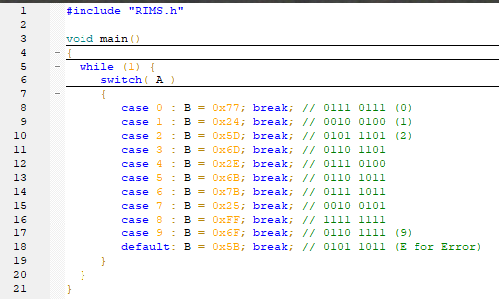

1. Screenshot when A3 A2 A1 A0 = 1001; **(1’)**

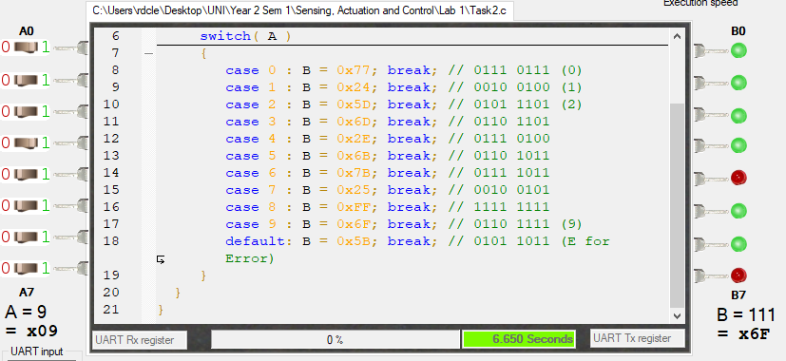

1. Screenshot when A3 A2 A1 A0 = 0101; **(1’)**

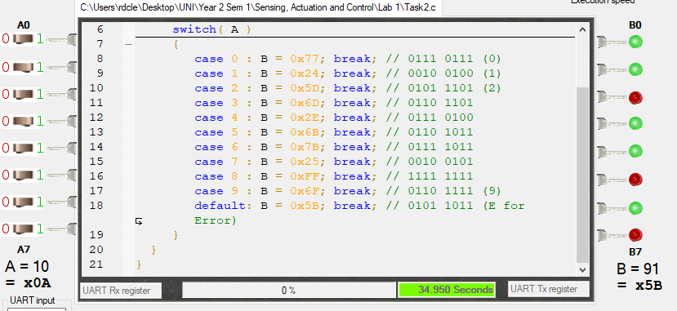

1. What is your idea if we need to display A7 A6 A5 A4 A3 A2 A1 A0 ? Explain your idea (an diagram as above will be good) **(2’)**

Allow the second nibble (A7 -> A5) to wire to a second rim micro chip that plugs the former second nibble into the new chips first nibble thus allowing for 2 digits from 1-9 to be shown.

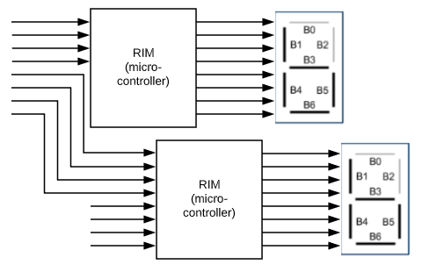

**Task 2.3: Parking lot sensors (4 Points)**

1. Screenshort of your source code; **(2’)**

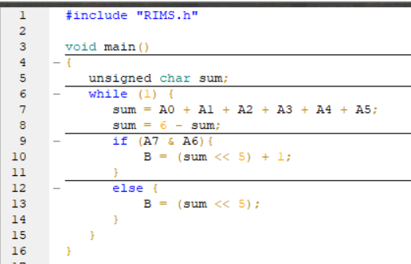

1. Screenshot the result when test A = 0011 0000; **(1’)**

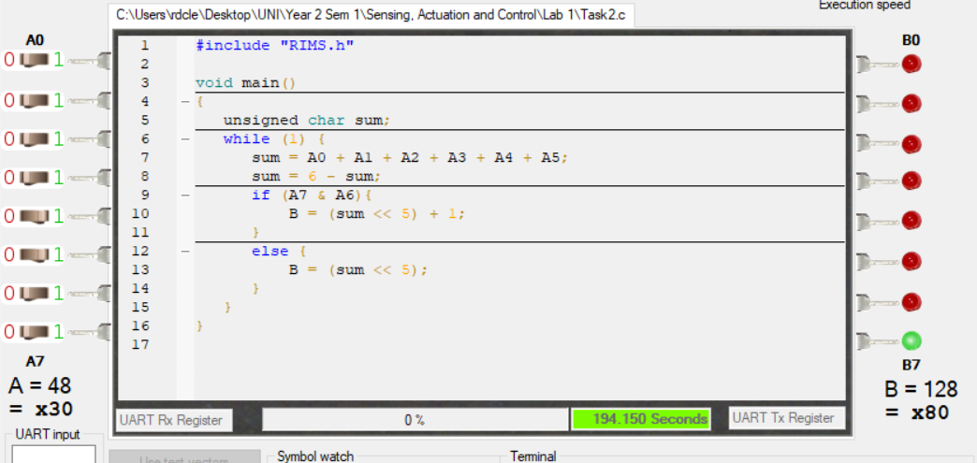

1. Screenshot the result when test A = 1000 1101; **(1’)**

